September Newsletter
GC Divers

Upcoming Events

USA Diving convention -September 11-17th.
We will get our annual meet schedule at this event.

Skatetown kick-off event
September 28th -Look for your invitation in your folder

October – Waiting to hear if the Houston teams will host their fall events.

AAU National Scores 2017
Group E (9 Under)
coach’s recommendation.
Group D (10-11)
Girls 1m-130 3m-150
Boys 1m-120 3m-125
Group C (12-13)
Girls 1m-205 3m-210
Boys 1m-210 3m-225
Group B (14-15)
Girls 1m-250 3m-260
Boys 1m-250 3m-270
Group A (16-18)
Girls 1m-305 3m-315
Boys 1m-365 3m-395

1101 Crockett Ct. Southlake, TX 76092
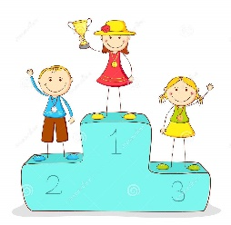
gcdivers@msn.com T: 817-424-0878
Dear Divers and Families,
We would like to welcome everyone back to a new year of diving. We have several new team members joining us and a few new coaches as well. Please welcome Coach Justin (Keller), Coach Alex (Southlake) and Coach Bailey (Southlake) to the GC Divers’ coaching staff.

Summer Champ Meet Results
AAU Nationals
GC Divers who attended AAU nationals did an outstanding job representing our club. We finished 3rd overall. This is a great meet for those divers making a step towards USA Diving nationals and our younger divers who get the opportunity to compete at a national level against other divers their own age.
USA Diving Nationals Jr/Sr
GC Divers is the number 1 team in the entire USA. USA Diving is our National governing body for the Olympic sport of diving. The USA Diving nationals requires a diver to qualify through a series of competitions. 28 GC Divers reached the top level of our sport and competed at the USA Diving nationals. The top 12 in each event score points and our divers scored enough points to be awarded the top team in the country. Hailey Hernandez was our high point athlete finishing 1st in two events and 2nd in her other event to earn a spot on the Jr Pan American Team. We are so proud of our divers who competed at this extremely competitive event.

Competition levels and what do they mean:
The coaches will help a diver decide which group they best fit into for competitions. When divers are placed properly, they have an opportunity to compete with other divers of their same level.
Most new team divers begin at the Future Champion level. This level stresses basic skill dives and ensures a diver is starting off with the correct technique on the simplest of dives.
Novice level is the next step for divers. This still requires skill dives but starts to add in some optional dives (dives of choice) into the mix. Some divers who competed J.O. last year may need to return to the Novice level until they learn their new age group J.O. requirements.
Junior Olympic (J.O.) level requires a list of basic dives (voluntary dives) which have a maximum degree of difficulty and a list of optional dives with no limit to degree of difficulty. As a diver gets older, the number of required dives increases.
What are the age brackets for competitions?
Divers compete the age they WILL BE Dec 31.
Age brackets include the following-
Junior Olympic Novice Future Champion
9U (Group E) 9U Gold
10-11 (Group D) 10-11 Silver
12-13 (Group C) 12-13 Bronze
14-15 (Group B) 14 and older
16-18 (Group A)
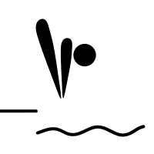

Trampoline Classes

Trampoline classes are available for all GC Divers and are scheduled at the Southlake pool. If you are interested, please email GCDivers@msn.com.

Private Lessons

If you would like to take a private lesson in the spotting belt, trampoline, or in the water, please email GCDivers@msn.com.

Parent question: What scores are good for my diver in a meet?
It is often difficult to get steady scores throughout a competition, but the most successful divers are the ones who are consistent. When a diver is performing new dives in competition, this consistency may suffer for a bit.
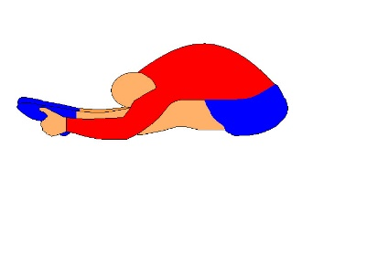
-Novice Divers-
Goal for meets is to earn 5s or better on every dive.
-J.O. Divers-
Goal for meets is to earn 6s or better on every dive.
-National divers-
Goal for meets is to earn 7s or better on every dive.
Example of a great pike stretch

Prize Dives: 3 meter.
Sponsored by coach Ida
Show her your dive and get your prize
Front 1 ½ earns a stuffed monkey
Front 2 ½ earns a tye dye chamois.
Back line up – trophy (11 & under divers)

